**Supplementary Figure 1a**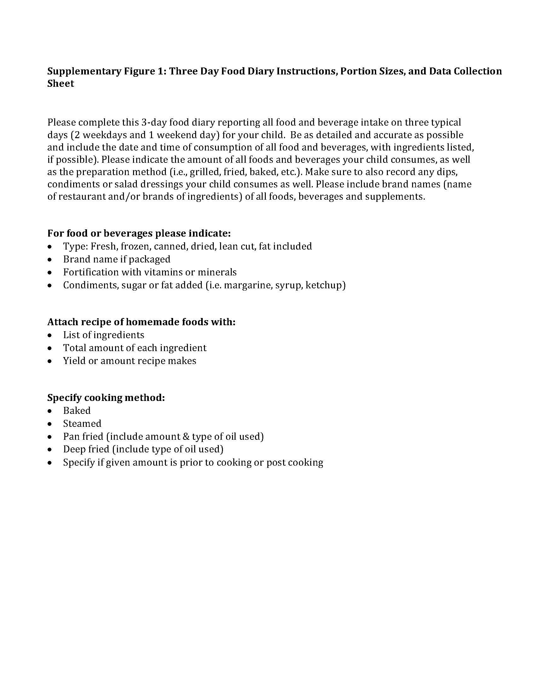

**Supplementary Figure 1b**

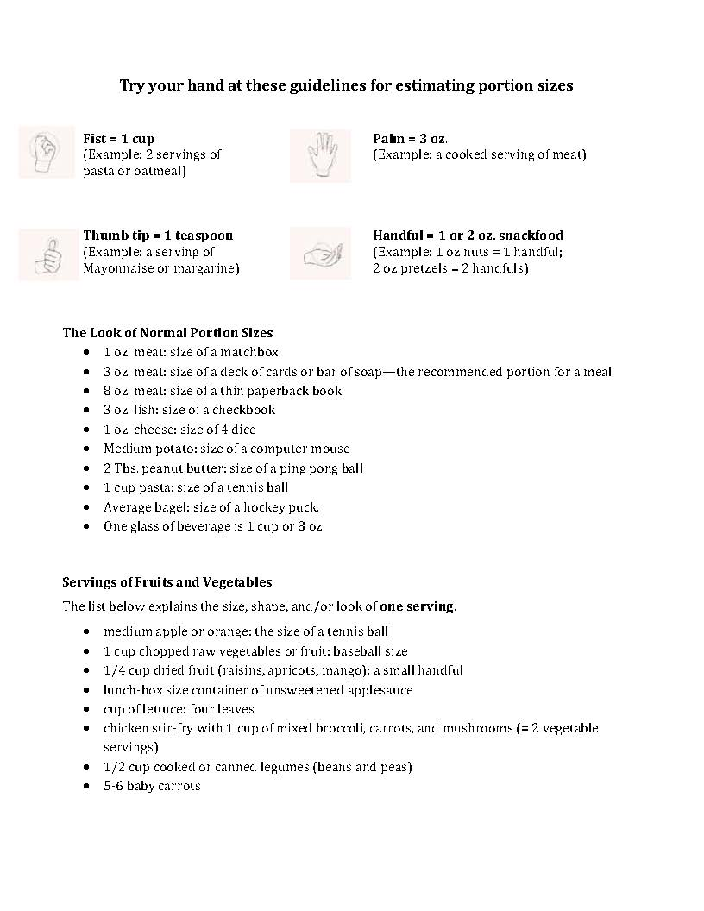

**Supplementary Figure 1c**

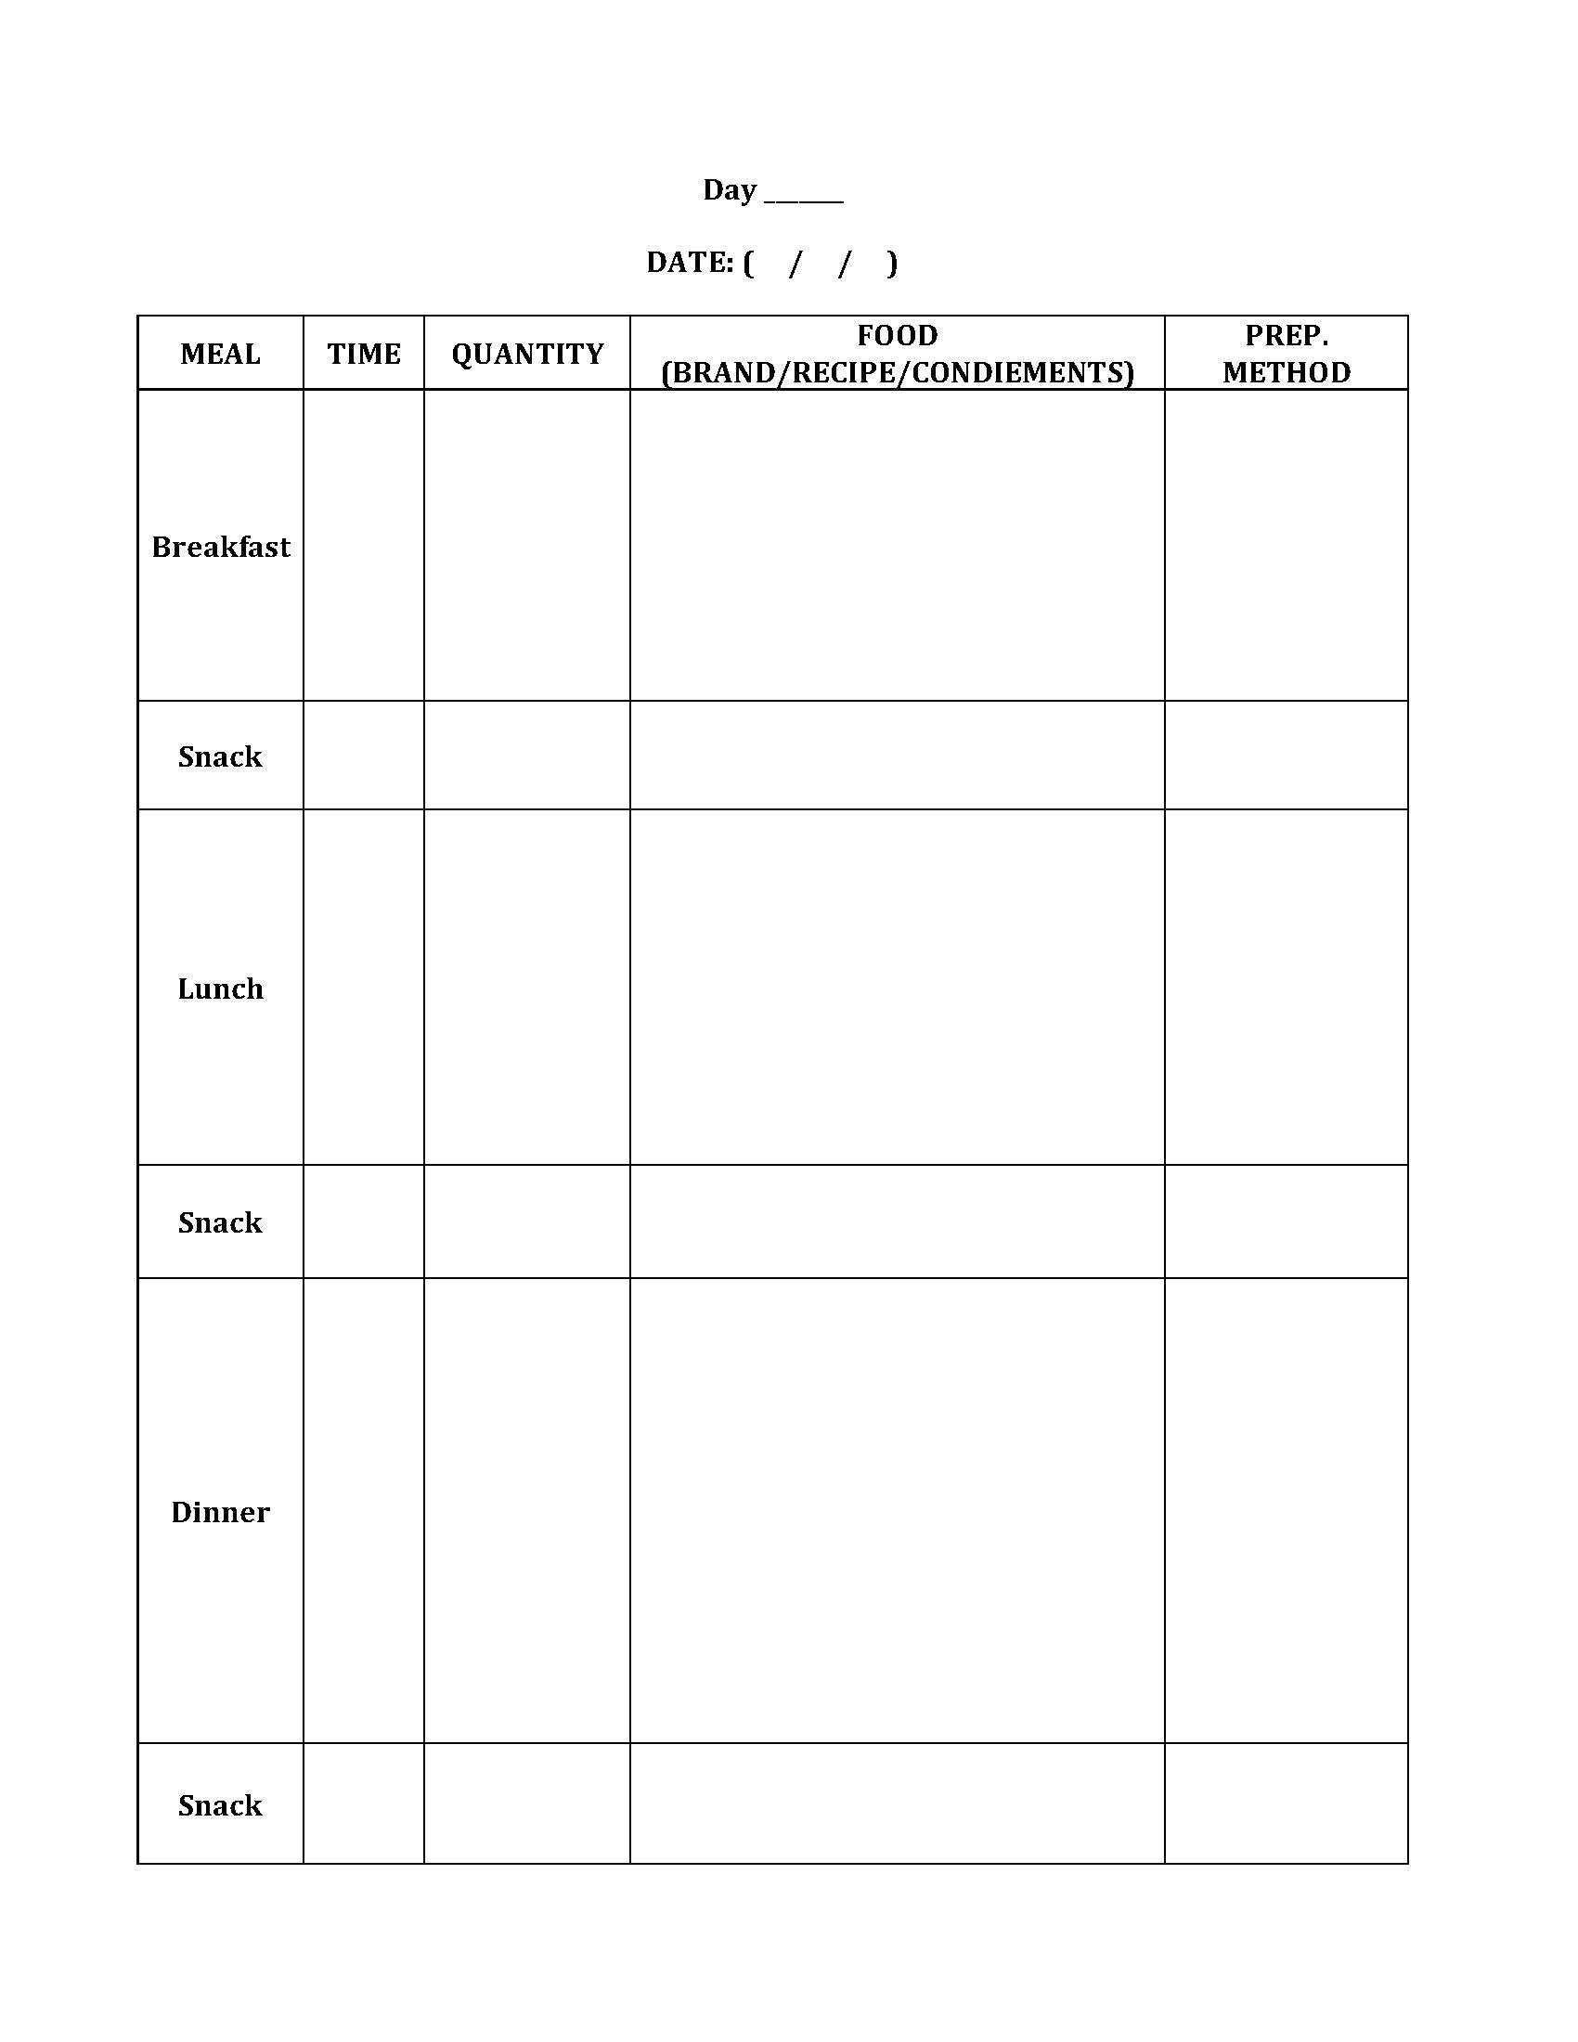

**Supplementary Figure 2a**

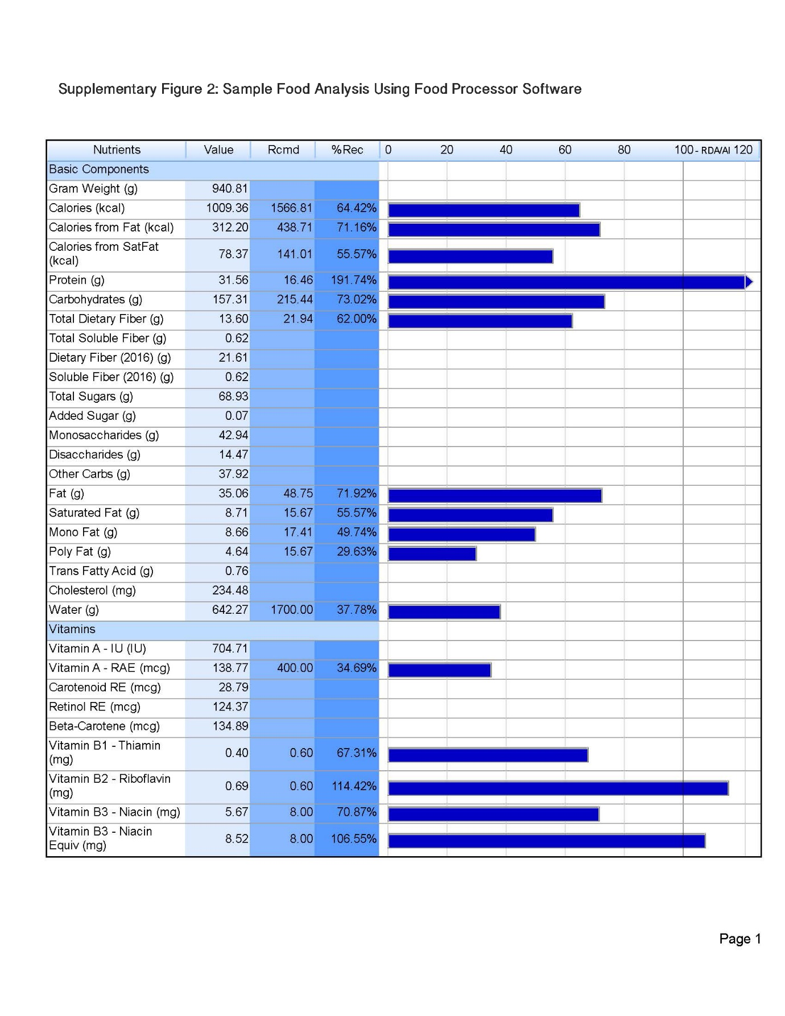**Supplementary Figure 2b**

